1- How many pods exist on the system?

**kubectl get pods**

**zero pods**

2- How many Nodes exist on the system?

**kubectl get nodes**



3- Create a new pod with the nginx image.

Image name: nginx

**kubectl run nginx --image=nginx**

4- Which nodes are these pods placed on?

kubectl get pods -o wide

5- Create pod from the below yaml using kubectl apply command

apiVersion: v1

kind: Pod

metadata:

name: webapp

namespace: default

spec:

containers:

- image: nginx

imagePullPolicy: Always

name: nginx

- image: agentx

imagePullPolicy: Always

name: agentx

**vim webapp.yaml**

**kubectl apply -f webapp.yaml**

6- How many containers are part of the pod webapp

**2 containers**

**kubectl describe pod webapp**

7- What images are used in the new webapp pod?

**2 images (agentx and nginx)**

**kubectl describe pod webapp**

8- What is the state of the container agentx in the pod webapp

**waiting**



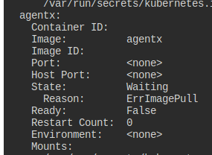

9- Why do you think the container agentx in pod webapp is in error?

**No image called agentx**

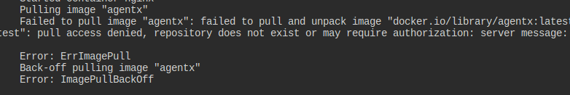**the error is ImagePullBlcakOFF**

10- Delete the webapp Pod.

**kubectl delete pod webapp**

11- Create a new pod with the name redis and with the image redis123.

* Name: redis
* Image Name: redis123

**kubectl run redis --image=redis123**

12- Now change the image on this pod to redis.

Once done, the pod should be in a running state.

**kubectl set image pod/redis redis=redis**

13- Create a pod called my-pod of image nginx:alpine

**kubectl run my-pod --image=nginx:alpine**

14- Delete the pod called my-pod

**kubectl delete pod my-pod**